**Steps to Force complete the Task**

* Login to asprd246 machine as prodsupp

/usr/localcw/bin/sudo su - m67007

/usr/localcw/bin/sudo su – prodsupp

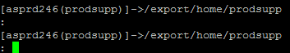

* Go to complete Directory: cd complete



* Type fc.run

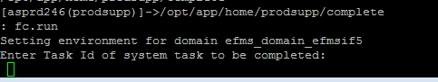

* Enter the Task ID and hit enter:

